**Problem sheet 4 :: experimental design**

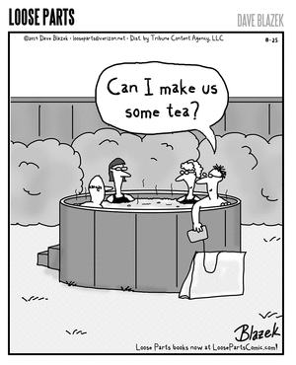

Tea is better than coffee. Let’s just get that out of the way before we start. ~~Many Most~~ ALL British people think this. Even those who say the exact opposite agree really, they’re just trying to be provocative and confrontational due to consuming too much caffeine. Yes, it may look like pretty much every other building you come across these days is a Starbucks, but tea is still more popular. Tea doesn’t need a global empire shoving it in people’s faces. Not after the last one, anyway.

The above paragraph is obviously exaggerated for comic effect (but only slightly), but it can’t be underestimated how important tea is to many people in Britain (and beyond of course). And because it’s so important, how it’s made becomes a serious issue. How long you leave the tea to brew, whether to put sugar in, what type of tea to use, and perhaps the biggest cause of disputes: if you put milk in your tea (which you should) do you put it in the cup before or after the boiling water?

Many arguments have been had about this. If anything is going to kick off another civil war in the UK, it is probably going to be this. What most people don’t know is that scientists settled this debate. Supposedly.

To test the recipe for the perfect cup of tea put forward in 1946 by George Orwell himself, Dr Stapley of Loughborough University established that putting the milk in after the boiling water is incorrect, as it causes the milk to heat unevenly (as opposed to pouring the water on top of it). This uneven heating of the milk causes the proteins in it to denature, meaning they lose their structure and “clump”, affecting the taste and contributing to that skin you get on the top. So when someone says they can tell if you put the milk in first or second in the tea you’ve made for them just by tasting it, turns out they probably can.

**Questions**

Four questions, each worth two marks with two marks for attendance.

We want to reproduce the experiment by Dr Stapley, i.e. we want to find out which method is the best between adding the milk before or after the boiling water. By “best” we mean that the tea will have a better taste.

Q1. Create an experimental design to test this, i.e. (a) what are your independent and dependent variables and how to you gather the feedback from the participants (what question do you ask?); (b) are you performing a between or within-subject experiment and why; (c) what is the task, i.e. what are you asking the participants to do; (d) are you using any kind of counterbalancing?; (e) how many participants do you think you will need and how many trial per participants you will do?

Q2. Let’s suppose you have asked participants to answer a questionnaire using a Likert scale for each cup of tea drunk. The scale is from 1 (not tasty) to 5 (very tasty). What kind of distribution you expect your data to follow: normal or skewed? Why?

Q3. You run your normality test and observe that assumption of normality is rejected for your Likert data, so your data is skewed. What statistical test will you be using to compare your two conditions (milk before, milk after)?

Q4. You are wondering what the effect of would be pouring the milk and the boiling water *at the same time*. You run the same experiment again but this time with 3 conditions: milk before, milk after or milk at-the-same-time. What do you need to change in your experimental design and why? What statistical test will you be using to compare your three conditions?

**Useful**

